

1. Introduction 2
2. Populating tux_fml_buffers and tux_services tables 2
3. Automatic Classes Generation for Tuxedo Services 2

Introduction
The purpose of this document is to detail the steps involved to automatically generate Java classes for tuxedo services.

Populating tux_fml_buffers and tux_services tables
As a first stage for automatic classes generation tux_fml_buffers and tux_services tables should be updated.

- Truncate tux_fml_buffers_old table and copy data from current tux_fml_buffers to tux_fml_buffers_old.
- Run SQL to check the differences between tux_fml_buffers_new and tux_fml_buffers and vice versa.


- Update IN_USE field in the tux_services_new table according to the tux_services table.

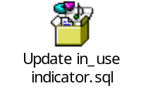
- Set IN_USE field to ‘Y’ manually for the new tuxedo services that will be in use.
- Update default values in the tux_fml_buffers_new

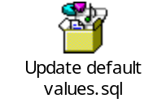
- Truncate tux_fml_buffers and tux_services tables and copy data from tux_fml_buffers_new and tux_services_new.

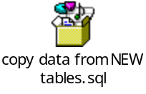

Automatic Classes Generation for Tuxedo Services
- Set IN_USE indicator in the tux_services table for the wanted service to ‘Y’.
- Open GenerateServiceClasses from the tools module
- Check if directories, specified in sSvcFileLoc and sParamFileLoc exist. If not, create them. If the directories exist remove all old data from them.
- Compile the class
- Run the class. If nothing is specified in the Program Parameters in the ‘Run’ window then all the services with IN_USE=’Y’ will be generated. For a specific service service name should be specified as a parameter (e.g. mmOpenFu).
- After classes are generated they should be copied manually to the development directory to
core/system/tuxedo/service and core/system/tuxedo/service/parameters
- Add the classes to CVS manually from IntelliJ after refreshing it.

